**8(a) Annual Review Preview**

Contents

**Eligibility** 4

**Confirm Eligibility** 4

**Changes** 5

**Adverse Actions** 5

**Entity-owned** 5

**8(a) Participant Benefits** 7

**Tribe/Holding Company Benefits** 8

**Tax Returns** 8

**Financial Statements** 9

**Revenue** 10

**Control** 10

**Outside Assistance** 10

**Distributions** 11

**Business Development** 11

**Mentor Protégé** 11

**Business Plan** 12

**Business Plan Update** 12

**Business Plan Update Section** 13

**Transitional Stage** 13

**Business Activity Targets** 14

**Steps for Growth** 14

**Marketing Capability Statement** 15

**Marketing Capability Statement Update** 15

**Marketing Capability Statement Certify Upload** 15

**8(a) Joint Venture Participant** 16

**Contracts** 17

**Bonding** 17

**Surplus Property** 18

**7J Training** 18

**Contract Forecast** 19

**Contributor - Disadvantaged Individual** 20

**Updates** 20

**Current Charges** 20

**Recent Arrests** 21

**Economic Disadvantage** 21

**Asset Transfers** 21

**Tax Return** 22

**Financial Data** 23

**Cash on Hand** 23

**Other Sources of Income** 24

**Notes Receivable** 25

**Retirement Accounts** 25

**Life Insurance** 26

**Stocks & Bonds** 26

**Real Estate – Primary Residence** 27

**Real Estate – Other** 28

**Personal Property** 29

**Notes Payable and Other Liabilities** 30

**Assessed Taxes** 30

**Nondisadvantaged Contributor** 31

**Current Charges** 31

**Recent Arrests** 31

**Updates** 32

**Spouse** 32

**Tax Return** 32

**Financial Data** 33

**Cash on Hand** 33

**Other Sources of Income** 34

**Notes Receivable** 35

**Retirement Accounts** 35

**Life Insurance** 36

**Stocks & Bonds** 36

**Real Estate – Primary Residence** 37

**Real Estate – Other** 38

**Personal Property** 39

**Notes Payable and Other Liabilities** 40

**Assessed Taxes** 40

**Eligibility**

**

**Changes**

**

**Entity-owned**

**8(a) Participant Benefits**

**Tribe/Holding Company Benefits**

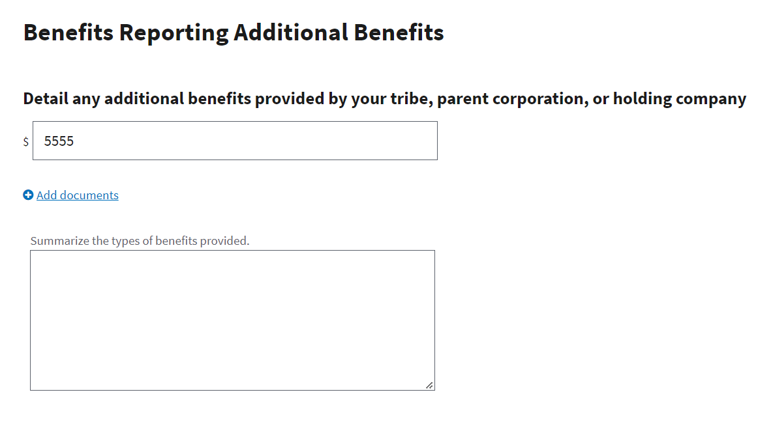

## **Tax Returns**

**

## **Revenue**

# **Control**

## **Outside Assistance**

## **Distributions**

# **Business Development**

**

**

**

**

**

**

**

**

**Marketing Capability Statement Update**

**8(a) Joint Venture Details**

## **Contracts**

**

**

**

## **Contract Forecast**

# **Contributor - Disadvantaged Individual**

## **Updates**

**

**Recent Arrests** 

# **Economic Disadvantage**

**

**

## **Financial Data**

**

**

**

**

**

**

**

### **Real Estate – Other**

**

### **Notes Payable and Other Liabilities**

### **Assessed Taxes**

# **Nondisadvantaged Contributor**

**

**Recent Arrests**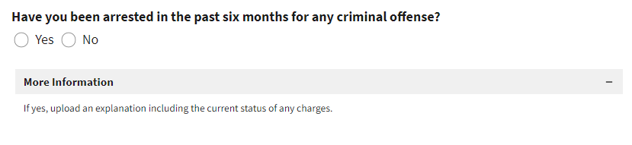

## **Updates**

# **Spouse**

## **Tax Return**

## **Financial Data**

**

**

**

**

**

**

**

### **Real Estate – Other**

**

### **Notes Payable and Other Liabilities**

### **Assessed Taxes**

