**8(a) Annual Review Preview**

Contents

**Eligibility** 4

Confirm Eligibility 4

Changes 5

Adverse Actions 5

Entity-owned 5

8(a) Participant Benefits 7

Tribe/Holding Company Benefits 8

**Tax Returns** 8

**Financial Statements** 9

**Revenue** 10

**Control** 10

**Outside Assistance** 10

**Distributions** 11

**Business Development** 11

**Mentor Protégé** 11

**Business Plan** 12

**Business Plan Update** 12

**Business Plan Update Section** 13

**Transitional Stage** 13

**Business Activity Targets** 14

**Steps for Growth** 14

**Marketing Capability Statement** 15

**Marketing Capability Statement Update** 15

**Marketing Capability Statement Certify Upload** 15

**8(a) Joint Venture Participant** 16

**Contracts** 17

**Bonding** 17

**Surplus Property** 18

**7J Training** 18

**Contract Forecast** 19

**Contributor - Disadvantaged Individual** 20

**Updates** 20

**Current Charges** 20

**Recent Arrests** 21

Economic Disadvantage 21

**Asset Transfers** 21

**Tax Return** 22

Financial Data 23

Cash on Hand 23

Other Sources of Income 24

Notes Receivable 25

Retirement Accounts 25

Life Insurance 26

Stocks & Bonds 26

Real Estate – Primary Residence 27

Real Estate – Other 28

Personal Property 29

Notes Payable and Other Liabilities 30

Assessed Taxes 30

**Eligibility**

Changes

Entity-owned

8(a) Participant Benefits

Tribe/Holding Company Benefits

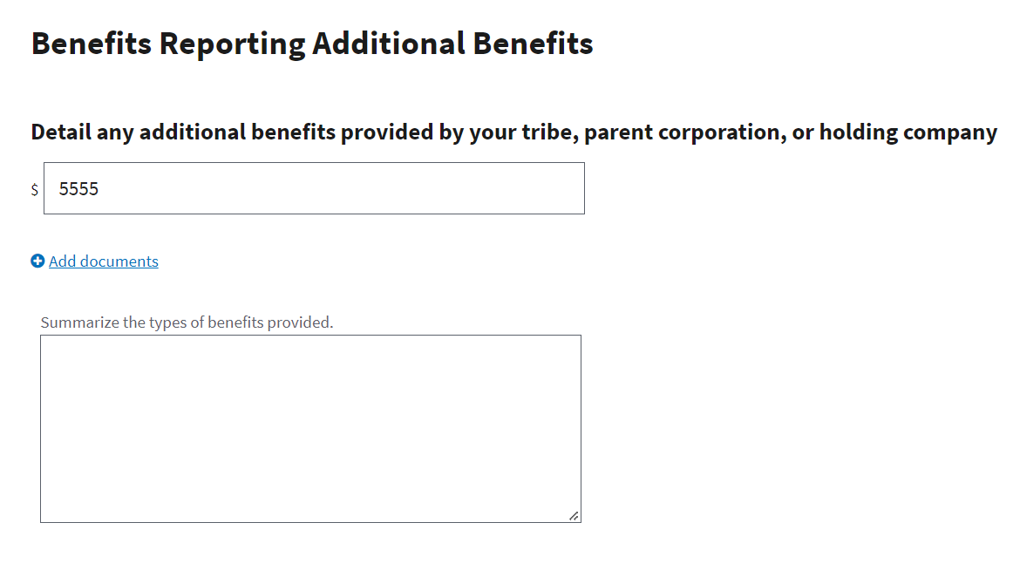

## **Tax Returns**

**

## **Revenue**

# **Control**

## **Outside Assistance**

## **Distributions**

# **Business Development**

**

**

**

**

**

**

**

**

**Marketing Capability Statement Update**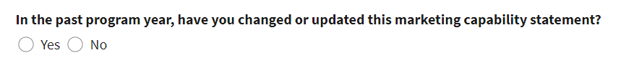

**8(a) Joint Venture Details**

## **Contracts**

**

**

**

## **Contract Forecast**

# **Contributor - Disadvantaged Individual**

## **Updates**

**

**Recent Arrests** 

# **Economic Disadvantage**

**

**

## Financial Data

### Real Estate – Other

### Notes Payable and Other Liabilities

### Assessed Taxes

